New Development at ECP 2024

- Translation Services:

- Google Translate widget on website (Spanish, French, German)

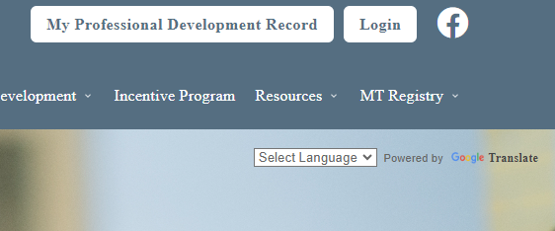

- Registry translated into Spanish/English – toggle on/off at top right in accounts
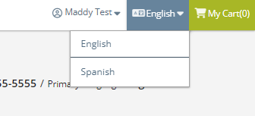
- Select Spanish for Email Communication Language in Personal tab to receive emails in Spanish
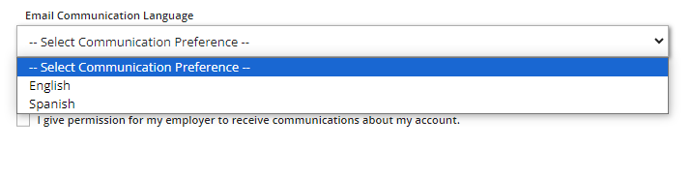
- Reports (PDR, Training Hour Requirements) also can be translated into Spanish if Spanish is toggled on at the top right corner
- Forms and User guides will also be translated (currently employment and high school forms). Found under MT Registry<Registry Forms on our website.

- First time Renewals

- Any classes taken before initial application submission to the registry will count toward the first renewal.
- Only for first renewal, orientation classes can only count once.
- Still must meet 16 hours yearly requirement as orientation classes add up to 14 hours.

- Training hours requirements

- Training hour requirements for different role types can be added; will be starting with subs to start getting them on registry.

- Badging

- Available this Spring or Summer
- Grouping trainings in a subject area together to create a badge; when all trainings are taken, earn a badge
- There will be a badge page to find badges; also on training calendar
- Badges will show up on PDR and registry certificate
- Benefits: Take trainings by interest/need; possible future incentives or career path levels; highlights expertise in area
- Only Phase 1 will come out this Spring; more features in future development

- Career Path

- Needed to change because we needed more options for people with non EC degrees
- Current path too weighted toward higher ed
- Needed to account for training hours and work experience as well
- Only changed Levels 2-6 for now; more levels may be added in future
- Survey will come out in Fall for feedback
- Career path will go live early June
- Levels will not drop down for anyone
- Will do career level changes for June, July, August renewals when they renew in those months
- We will manually start changing levels with Level 6, and work our way down to Level 2
- You do not need to ask for level changes during this process

